Example Network Design Report

This is an example report created with Ekahau Site Survey Pro.
You can freely customize the MS Word Template, and ESS will generate the report based on the template.

Customer Requirements

Coverage Requirements

signal strength at least | -70.0 dBm
signal-to-noise ratio at least | 15.0 dB
data rate at least | 6 Mbps
number of access points at least | 2 | when signal strength at least -80.0 dBm
ping round trip time at most | 200.0 ms
Packet loss at most | 5.0 %

Capacity Requirements
Amount | Device
900 | Laptop
600 | AC Smartphone
50 | Tablet

Coverage Areas

Map | Name | Coverage Area
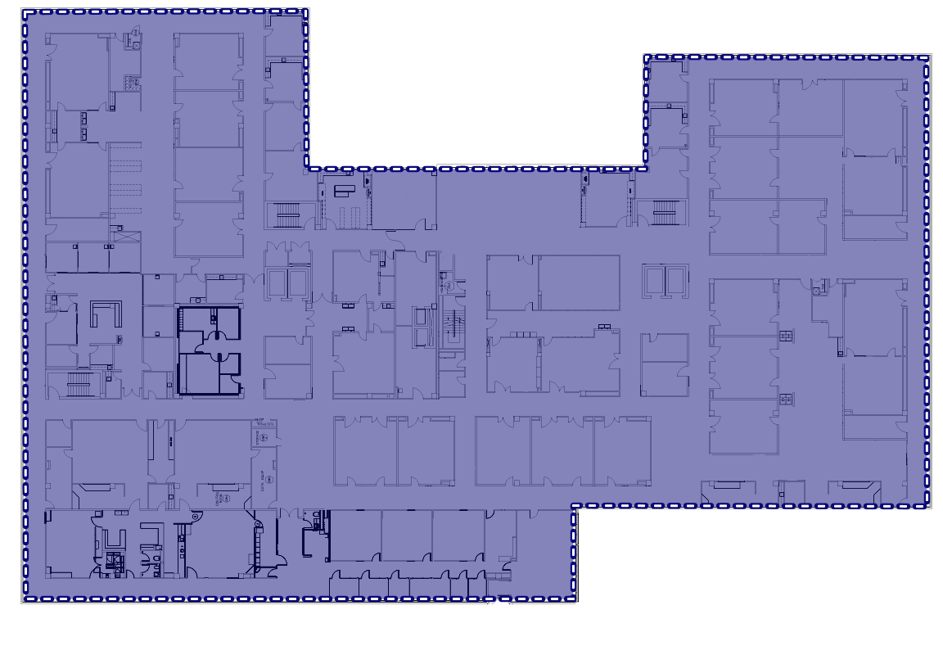 | Floor 1 | 3,458.1 m²
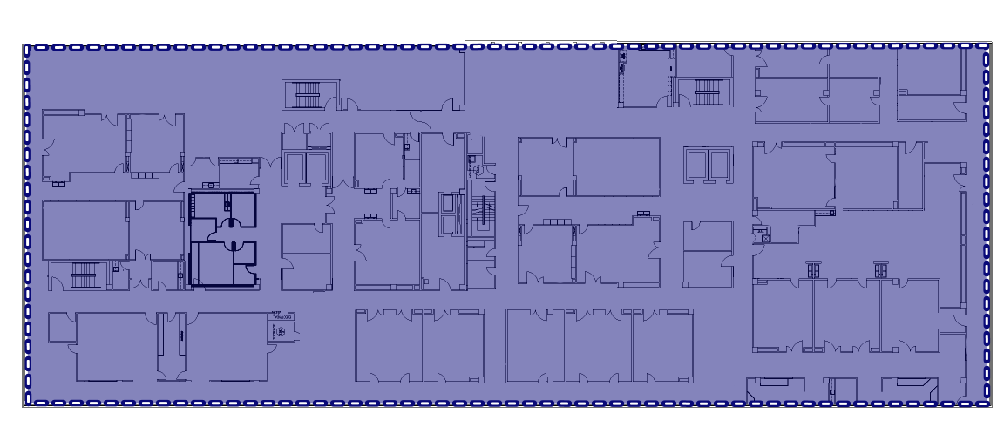 | Floor 2 | 2,471.6 m²
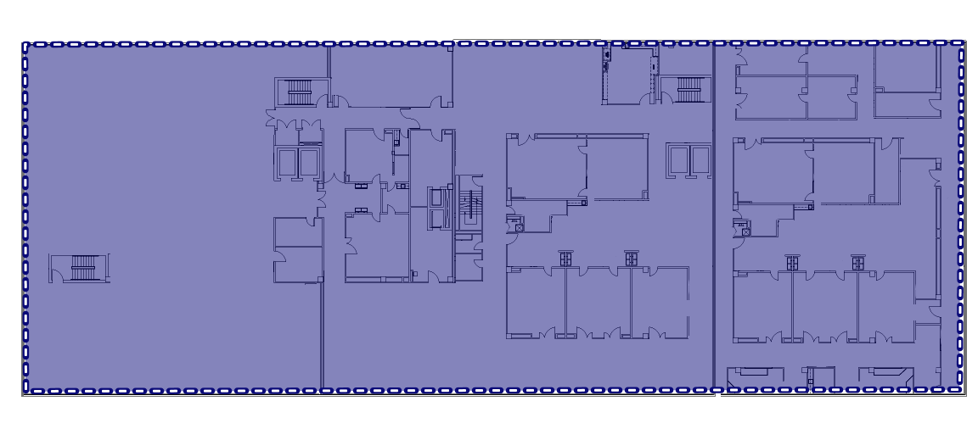 | Floor 3 | 2,433.9 m²

Total coverage area: 8,363.6 m²

Map Floor 1

Survey Routes and AP Locations

Access Point Locations

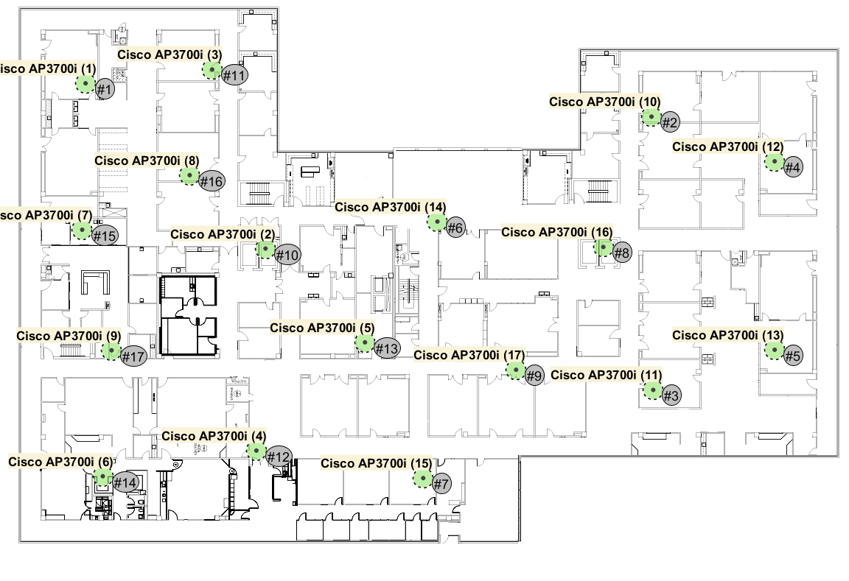

Access Points
Name: Cisco AP3700i (1) (#1) | Notes:
Radio on channel: 6
Networks:
Radio on channel: 36
Networks:

Name: Cisco AP3700i (10) (#2) | Notes:
Radio on channel: 1
Networks:
Radio on channel: 104
Networks:

Name: Cisco AP3700i (11) (#3) | Notes:
Radio on channel: 11
Networks:
Radio on channel: 64
Networks:

Name: Cisco AP3700i (12) (#4) | Notes:
Radio on channel: 11
Networks:
Radio on channel: 44
Networks:

Name: Cisco AP3700i (13) (#5) | Notes:
Radio on channel: 1
Networks:
Radio on channel: 108
Networks:

Name: Cisco AP3700i (14) (#6) | Notes:
Radio on channel: 11
Networks:
Radio on channel: 52
Networks:

Name: Cisco AP3700i (15) (#7) | Notes:
Radio on channel: 11
Networks:
Radio on channel: 104
Networks:

Name: Cisco AP3700i (16) (#8) | Notes:
Radio on channel: 6
Networks:
Radio on channel: 136
Networks:

Name: Cisco AP3700i (17) (#9) | Notes:
Radio on channel: 1
Networks:
Radio on channel: 116
Networks:

Name: Cisco AP3700i (2) (#10) | Notes:
Radio on channel: 11
Networks:
Radio on channel: 60
Networks:

Name: Cisco AP3700i (3) (#11) | Notes:
Radio on channel: 11
Networks:
Radio on channel: 56
Networks:

Name: Cisco AP3700i (4) (#12) | Notes:
Radio on channel: 1
Networks:
Radio on channel: 124
Networks:

Name: Cisco AP3700i (5) (#13) | Notes:
Radio on channel: 6
Networks:
Radio on channel: 40
Networks:

Name: Cisco AP3700i (6) (#14) | Notes:
Radio on channel: 11
Networks:
Radio on channel: 112
Networks:

Name: Cisco AP3700i (7) (#15) | Notes:
Radio on channel: 11
Networks:
Radio on channel: 100
Networks:

Name: Cisco AP3700i (8) (#16) | Notes:
Radio on channel: 1
Networks:
Radio on channel: 120
Networks:

Name: Cisco AP3700i (9) (#17) | Notes:
Radio on channel: 6
Networks:
Radio on channel: 48
Networks:

Network Health

2,4 GHz

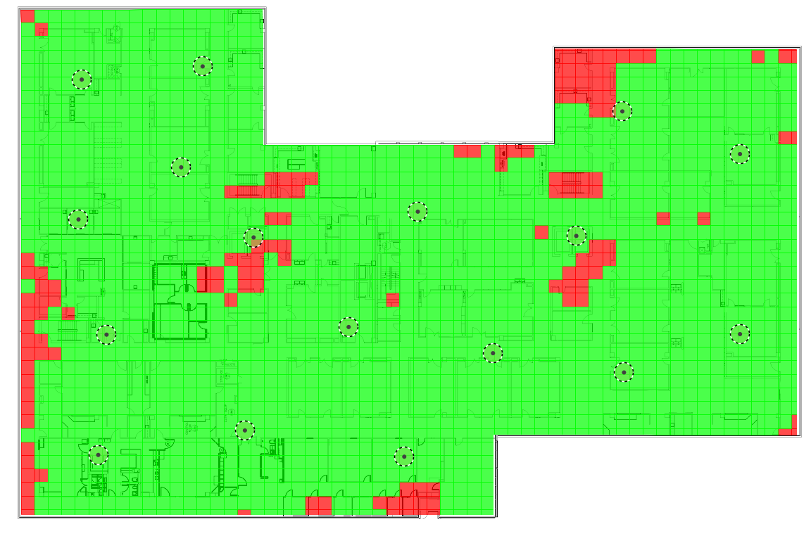

5 GHz
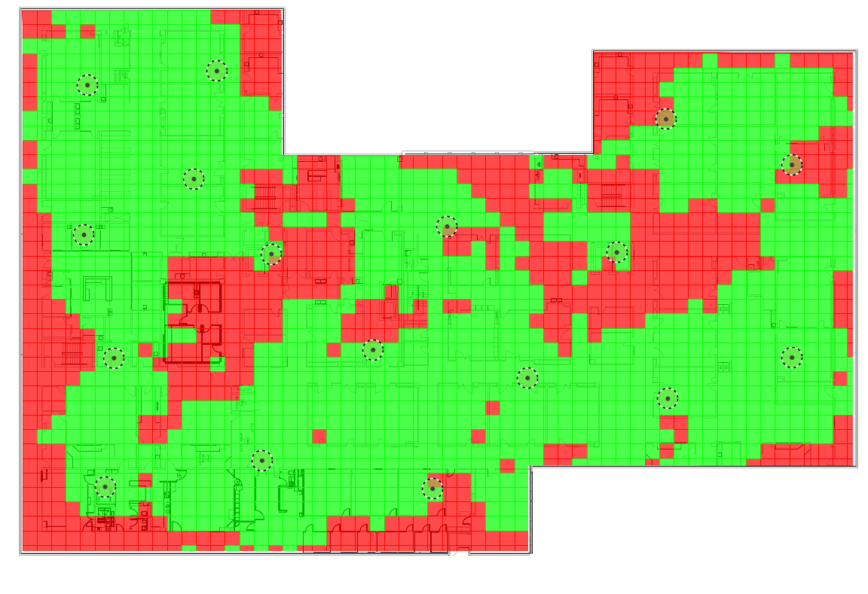

Coverage, Interference and SNR

Signal Strength 2.4 GHz
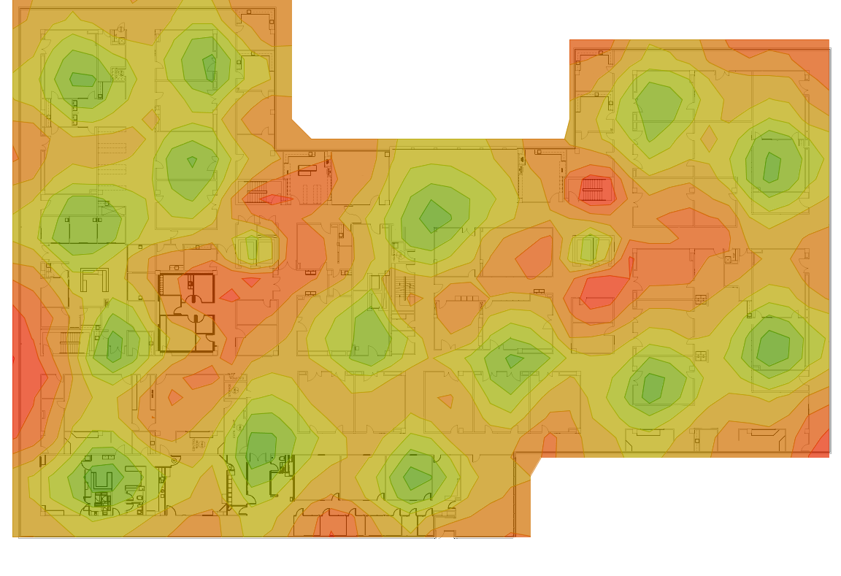

Signal Strength 5 GHz
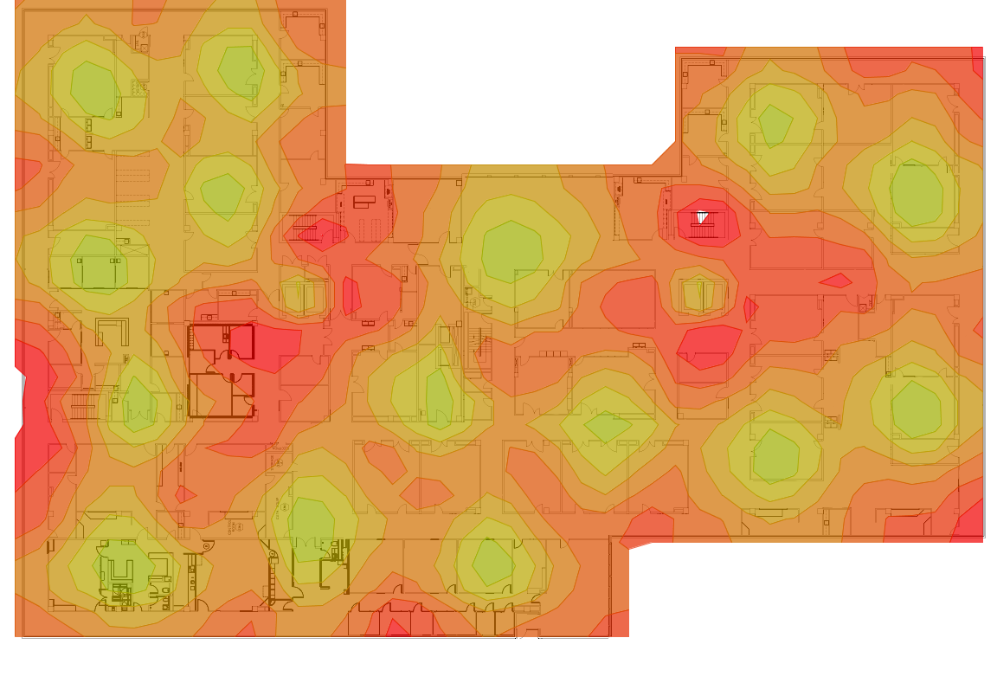

Per-Access Point Coverage 2.4 GHz

Cisco AP3700i (1) @ Channel 6
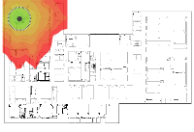
Cisco AP3700i (10) @ Channel 1
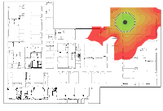
Cisco AP3700i (11) @ Channel 11
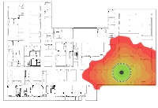
Cisco AP3700i (12) @ Channel 11
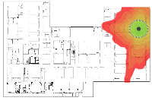
Cisco AP3700i (13) @ Channel 1
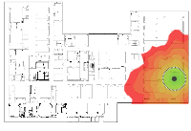
Cisco AP3700i (14) @ Channel 11
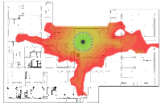
Cisco AP3700i (15) @ Channel 11
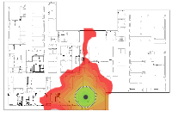
Cisco AP3700i (16) @ Channel 6
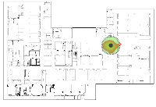
Cisco AP3700i (17) @ Channel 1
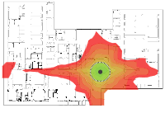
Cisco AP3700i (2) @ Channel 11
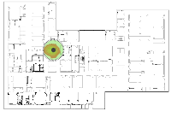
Cisco AP3700i (3) @ Channel 11
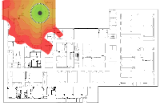
Cisco AP3700i (4) @ Channel 1
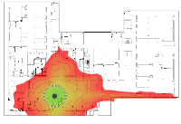
Cisco AP3700i (5) @ Channel 6
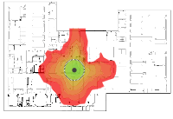
Cisco AP3700i (6) @ Channel 11
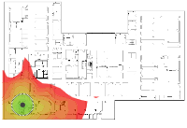
Cisco AP3700i (7) @ Channel 11
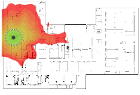
Cisco AP3700i (8) @ Channel 1
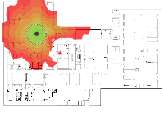
Cisco AP3700i (9) @ Channel 6
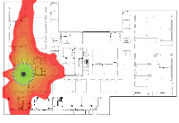

Per-Access Point Coverage 5 GHz

Cisco AP3700i (1) @ Channel 36
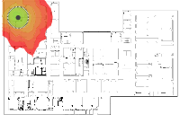
Cisco AP3700i (10) @ Channel 104
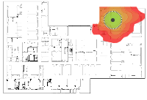
Cisco AP3700i (11) @ Channel 64
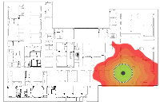
Cisco AP3700i (12) @ Channel 44
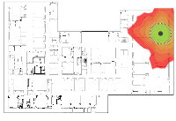
Cisco AP3700i (13) @ Channel 108
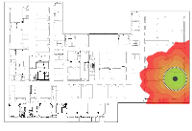
Cisco AP3700i (14) @ Channel 52
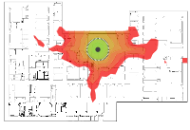
Cisco AP3700i (15) @ Channel 104
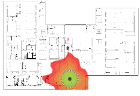
Cisco AP3700i (16) @ Channel 136
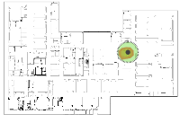
Cisco AP3700i (17) @ Channel 116
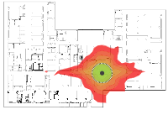
Cisco AP3700i (2) @ Channel 60
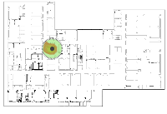
Cisco AP3700i (3) @ Channel 56
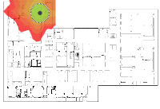
Cisco AP3700i (4) @ Channel 124
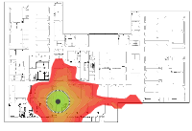
Cisco AP3700i (5) @ Channel 40
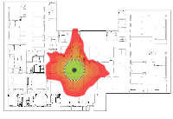
Cisco AP3700i (6) @ Channel 112
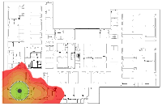
Cisco AP3700i (7) @ Channel 100
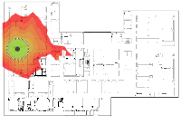
Cisco AP3700i (8) @ Channel 120
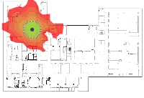
Cisco AP3700i (9) @ Channel 48
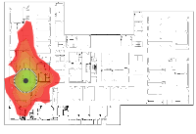

Interference 2.4 GHz
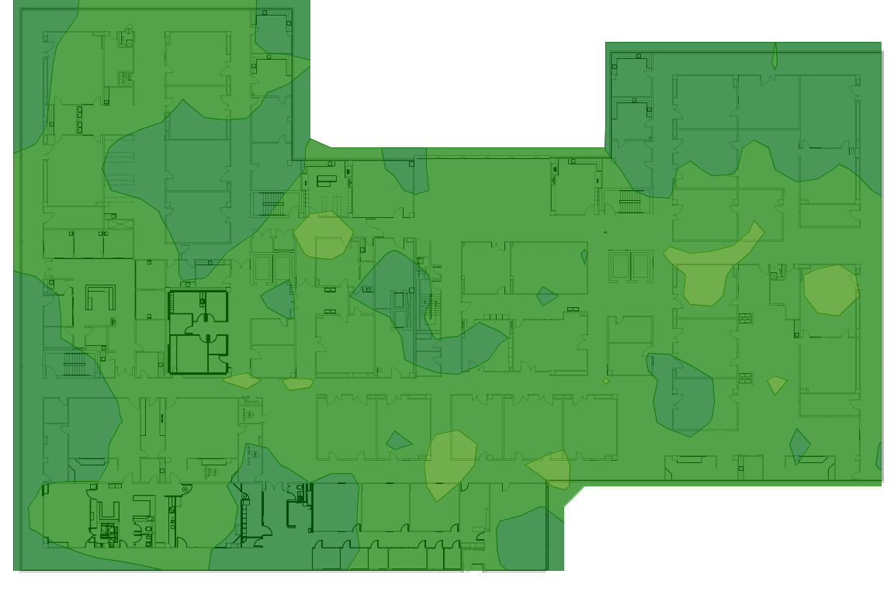

Interference 5 GHz
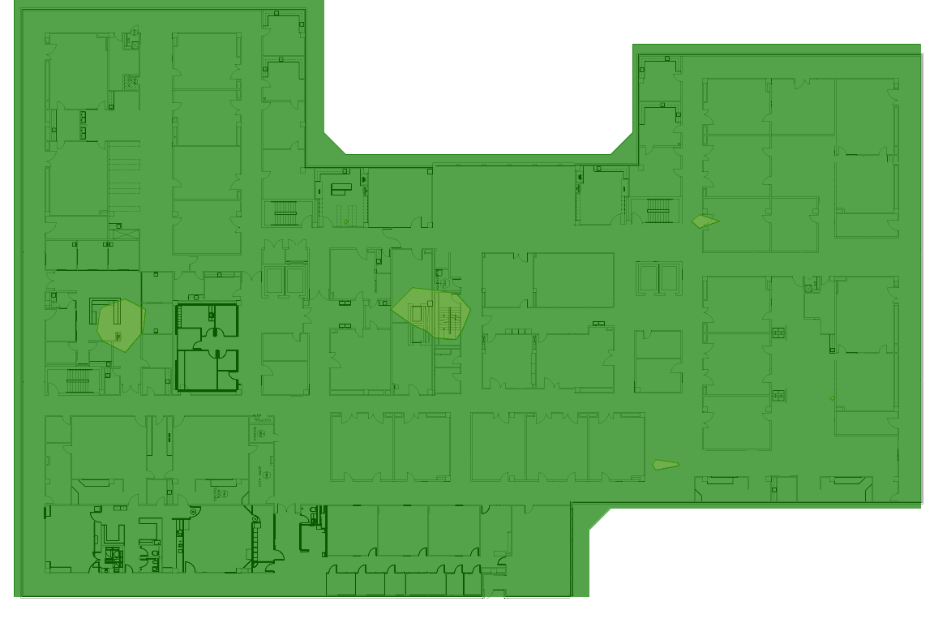

SNR 2.4 GHz
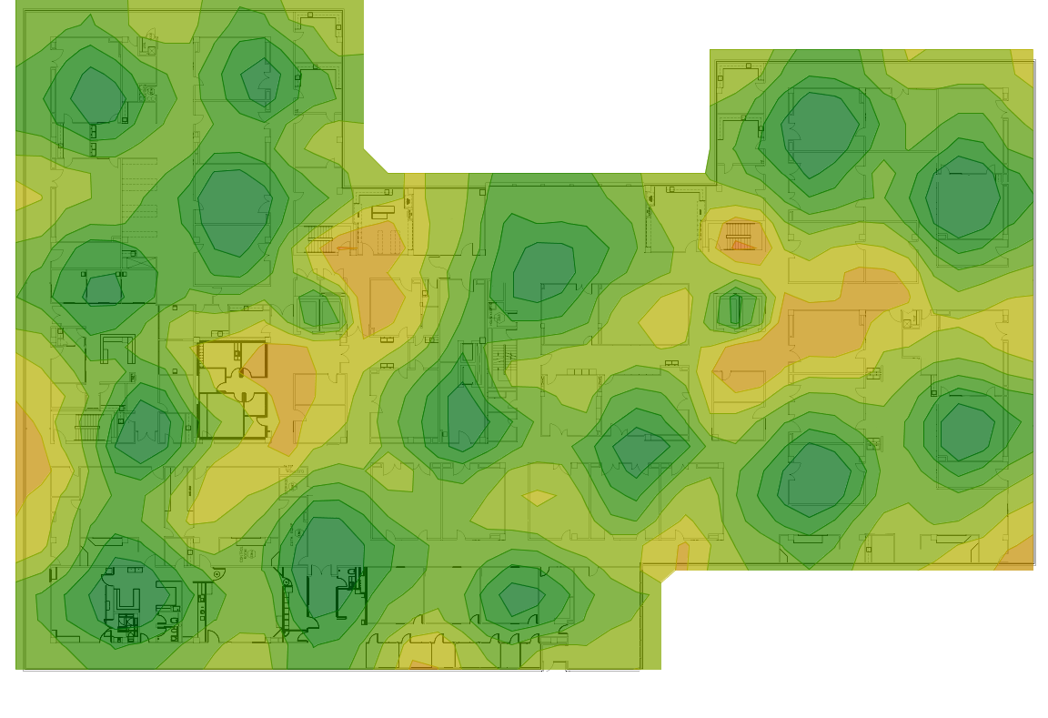

SNR 5 GHz
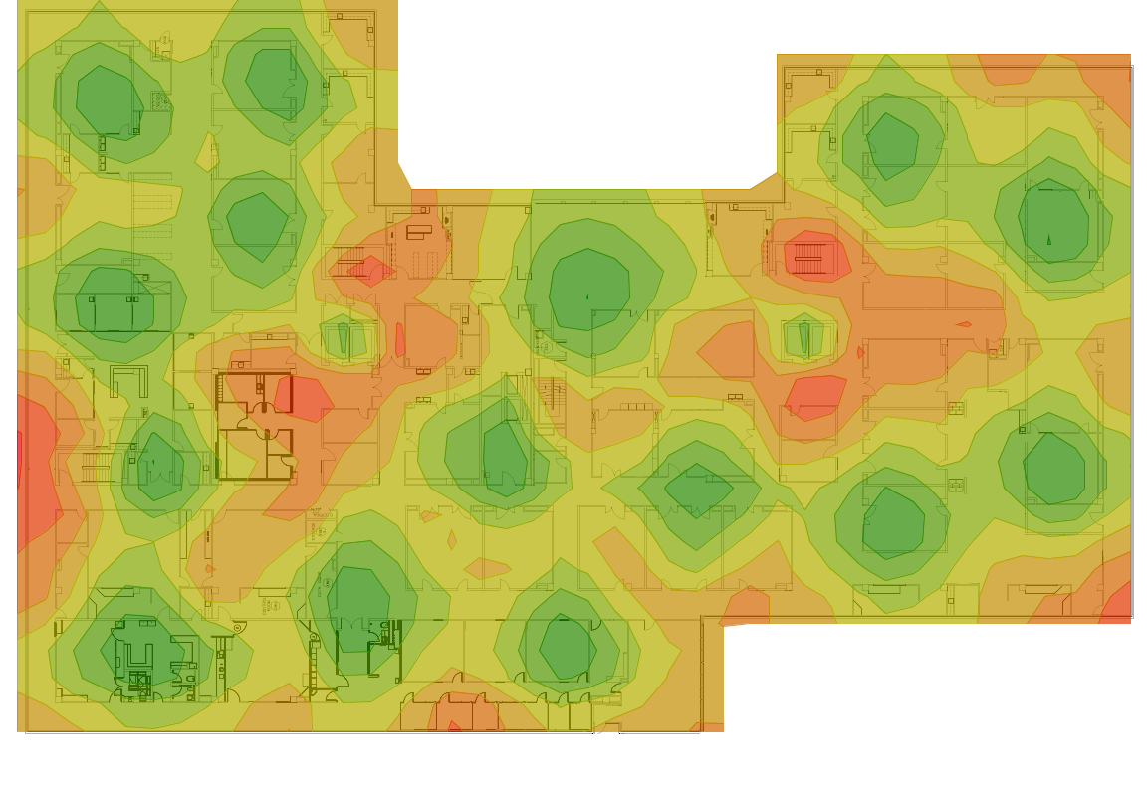

Capacity

Number of devices on this floor | Device
372 / 900 | Laptop
248 / 600 | AC Smartphone
21 / 50 | Tablet

Capacity Health 2,4 GHz
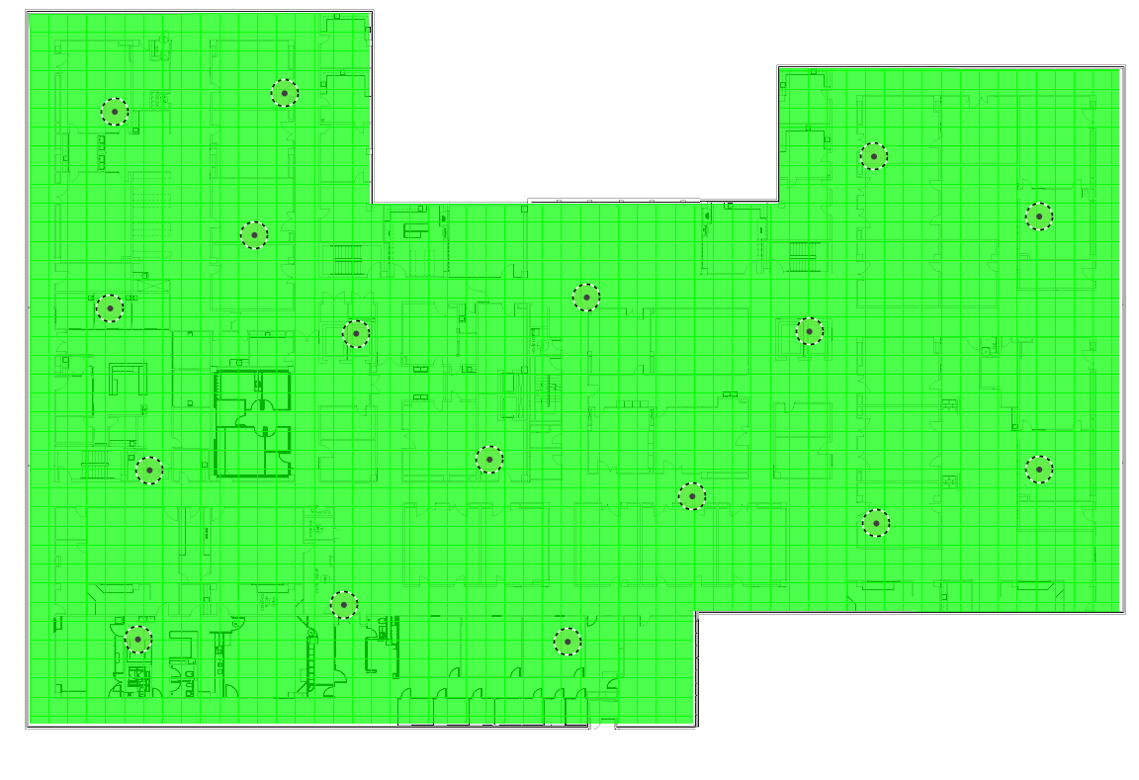

Capacity Health 5 GHz
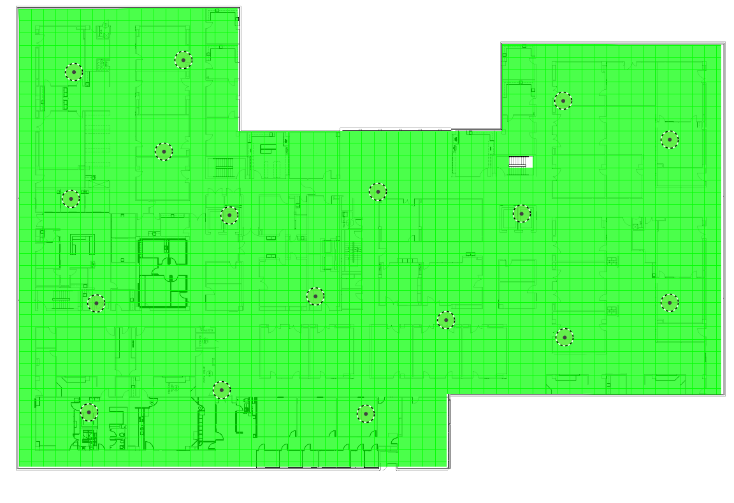

Associated Clients 2,4 GHz
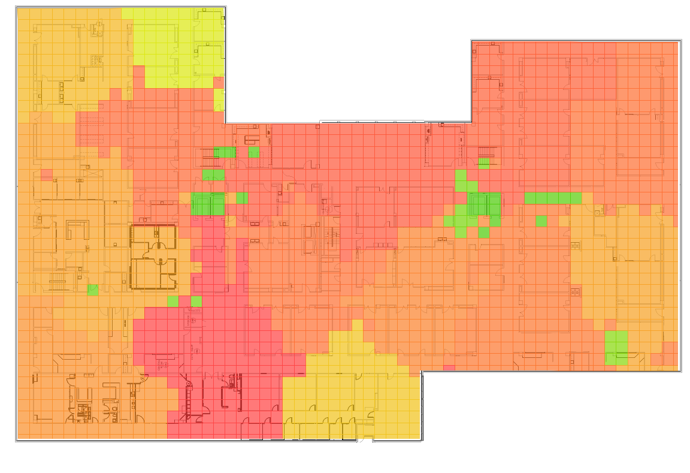

Associated Clients 5 GHz
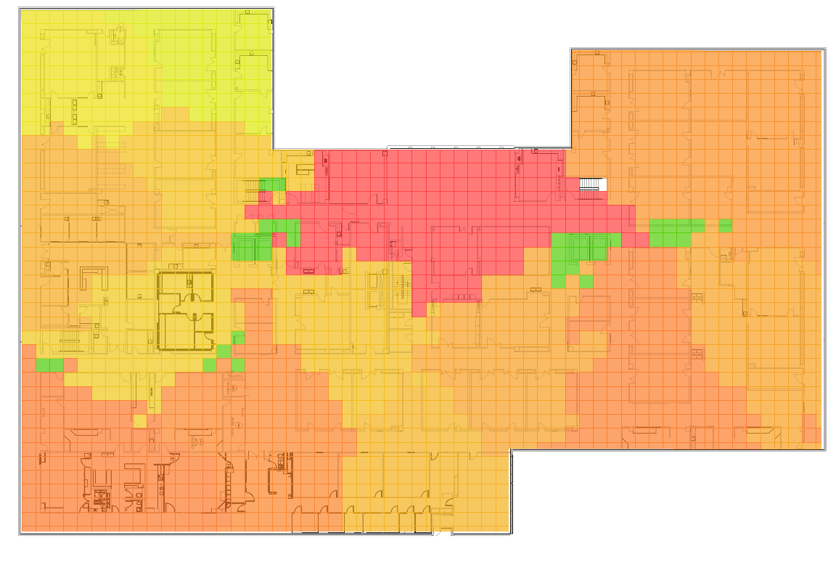

AP Serving Areas
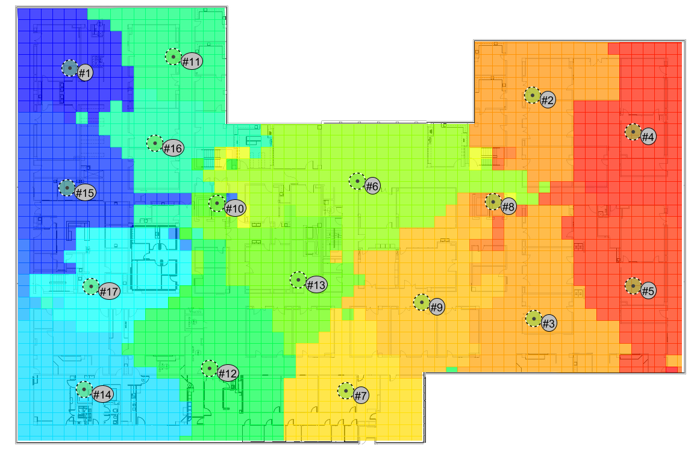

Map Floor 2

Survey Routes and AP Locations

Access Point Locations
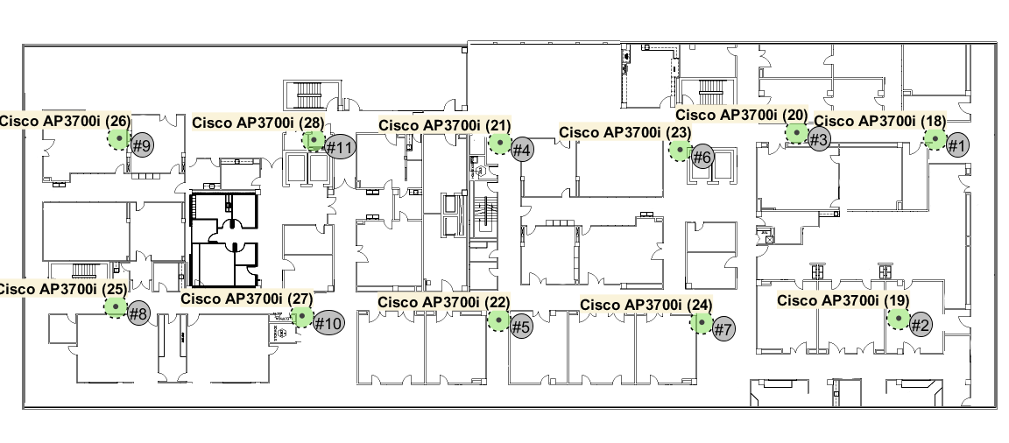
Access Points
Name: Cisco AP3700i (18) (#1) | Notes:
Radio on channel: 1
Networks:
Radio on channel: 64
Networks:

Name: Cisco AP3700i (19) (#2) | Notes:
Radio on channel: 6
Networks:
Radio on channel: 116
Networks:

Name: Cisco AP3700i (20) (#3) | Notes:
Radio on channel: 11
Networks:
Radio on channel: 136
Networks:

Name: Cisco AP3700i (21) (#4) | Notes:
Radio on channel: 1
Networks:
Radio on channel: 40
Networks:

Name: Cisco AP3700i (22) (#5) | Notes:
Radio on channel: 11
Networks:
Radio on channel: 124
Networks:

Name: Cisco AP3700i (23) (#6) | Notes:
Radio on channel: 6
Networks:
Radio on channel: 104
Networks:

Name: Cisco AP3700i (24) (#7) | Notes:
Radio on channel: 1
Networks:
Radio on channel: 52
Networks:

Name: Cisco AP3700i (25) (#8) | Notes:
Radio on channel: 1
Networks:
Radio on channel: 132
Networks:

Name: Cisco AP3700i (26) (#9) | Notes:
Radio on channel: 6
Networks:
Radio on channel: 48
Networks:

Name: Cisco AP3700i (27) (#10) | Notes:
Radio on channel: 6
Networks:
Radio on channel: 60
Networks:

Name: Cisco AP3700i (28) (#11) | Notes:
Radio on channel: 11
Networks:
Radio on channel: 112
Networks:

Network Health

2,4 GHz
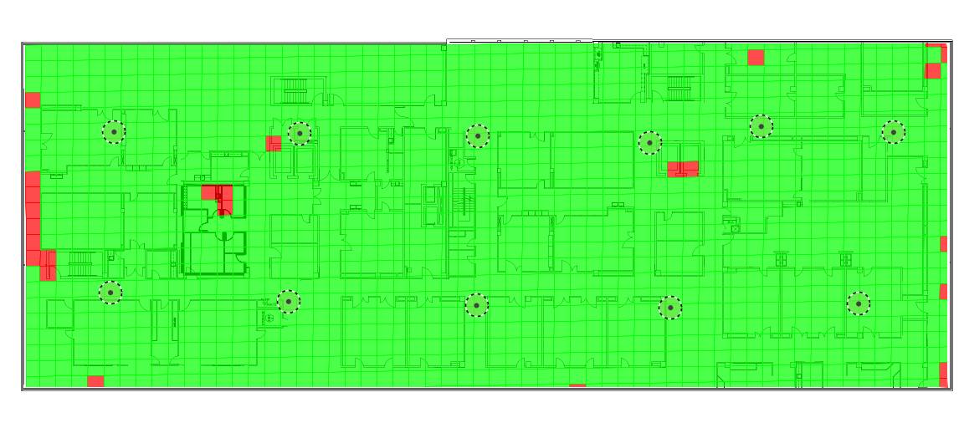

5 GHz
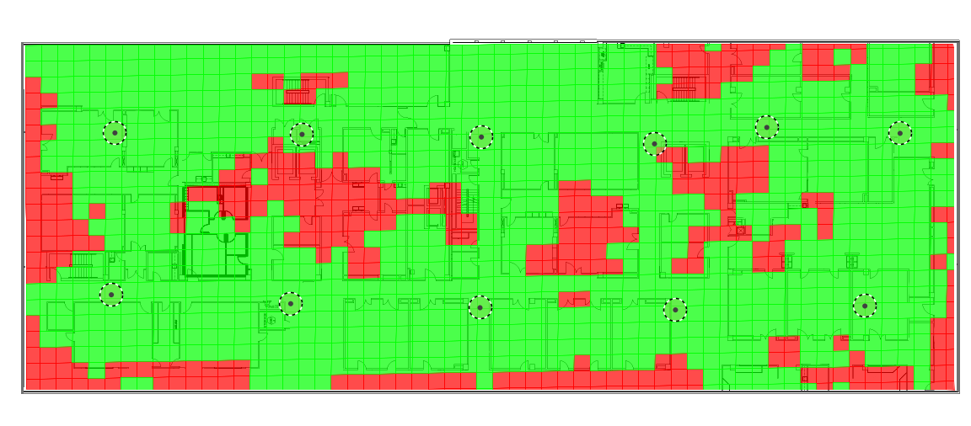

Coverage, Interference and SNR

Signal Strength 2.4 GHz
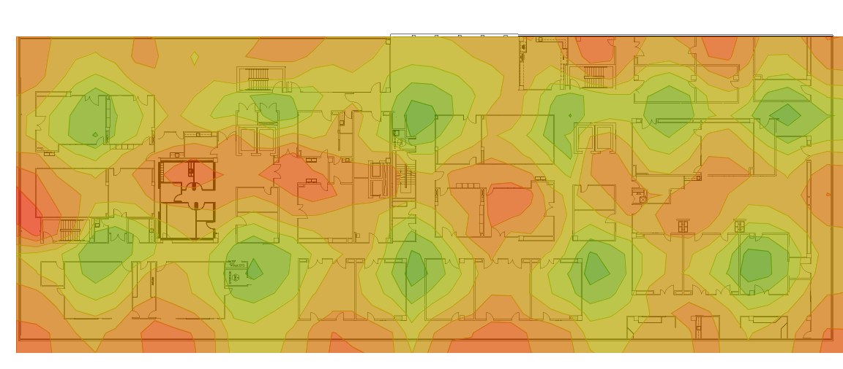

Signal Strength 5 GHz
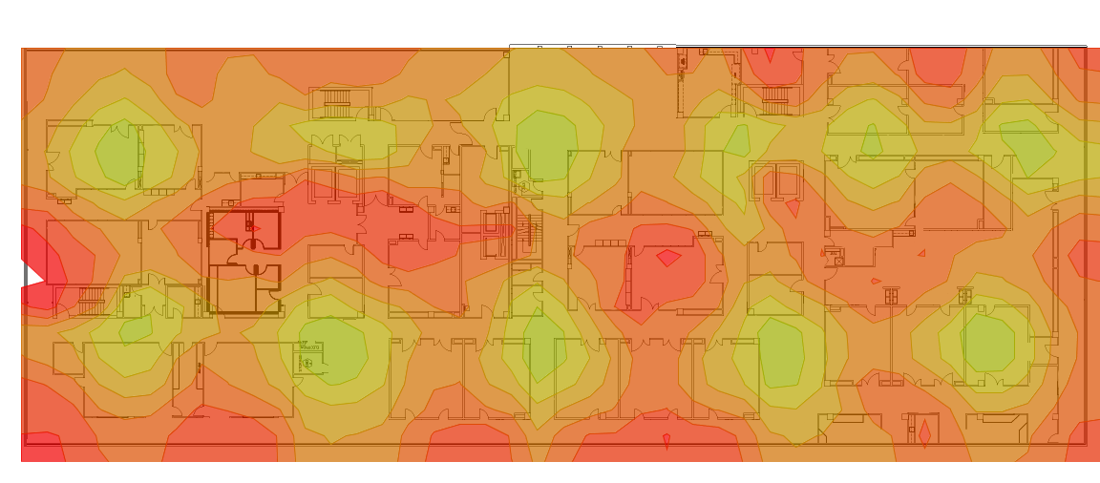

Access Point Coverage 2.4 GHz

Cisco AP3700i (18) @ Channel 1
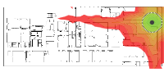
Cisco AP3700i (19) @ Channel 6
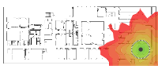
Cisco AP3700i (20) @ Channel 11
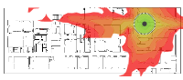
Cisco AP3700i (21) @ Channel 1
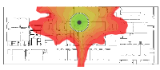
Cisco AP3700i (22) @ Channel 11
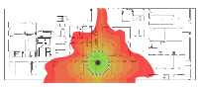
Cisco AP3700i (23) @ Channel 6
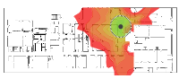
Cisco AP3700i (24) @ Channel 1
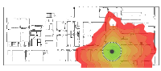
Cisco AP3700i (25) @ Channel 1
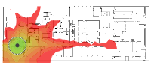
Cisco AP3700i (26) @ Channel 6
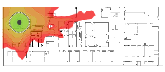
Cisco AP3700i (27) @ Channel 6
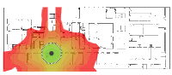
Cisco AP3700i (28) @ Channel 11
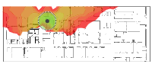

Access Point Coverage 5 GHz

Cisco AP3700i (18) @ Channel 64
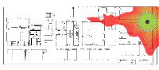
Cisco AP3700i (19) @ Channel 116
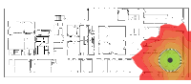
Cisco AP3700i (20) @ Channel 136
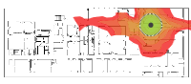
Cisco AP3700i (21) @ Channel 40
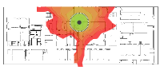
Cisco AP3700i (22) @ Channel 124
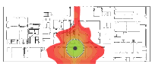
Cisco AP3700i (23) @ Channel 104
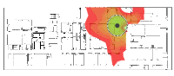
Cisco AP3700i (24) @ Channel 52
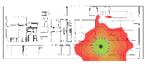
Cisco AP3700i (25) @ Channel 132
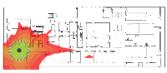
Cisco AP3700i (26) @ Channel 48
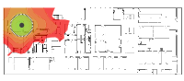
Cisco AP3700i (27) @ Channel 60
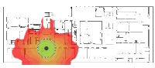
Cisco AP3700i (28) @ Channel 112
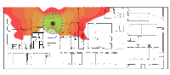

Interference 2.4 GHz
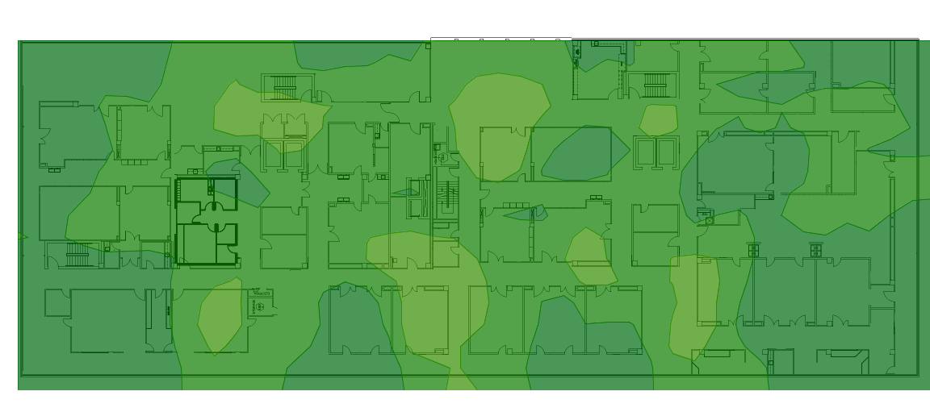

Interference 5 GHz
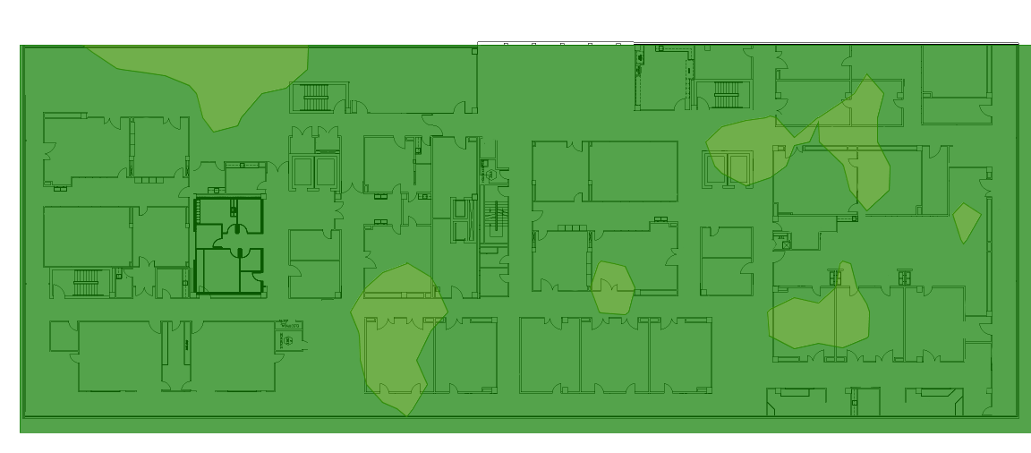

SNR 2.4 GHz
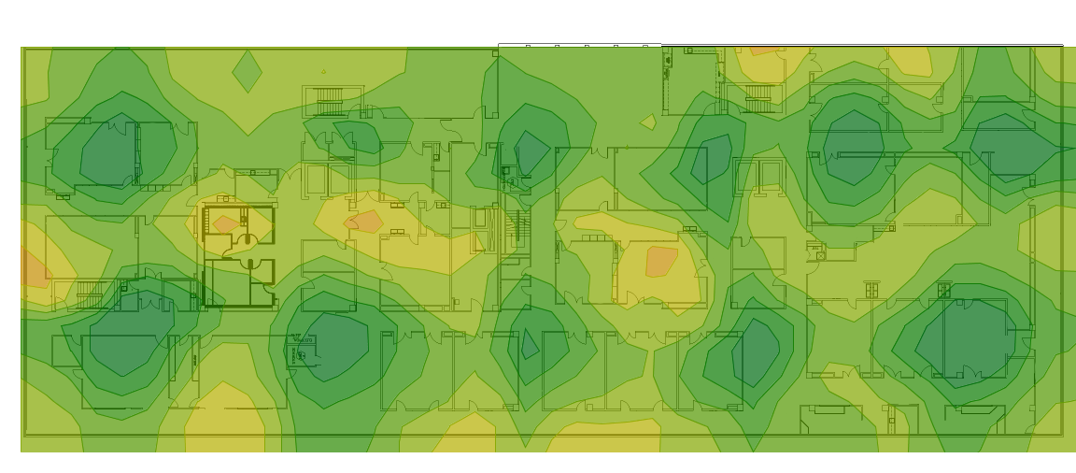

SNR 5 GHz
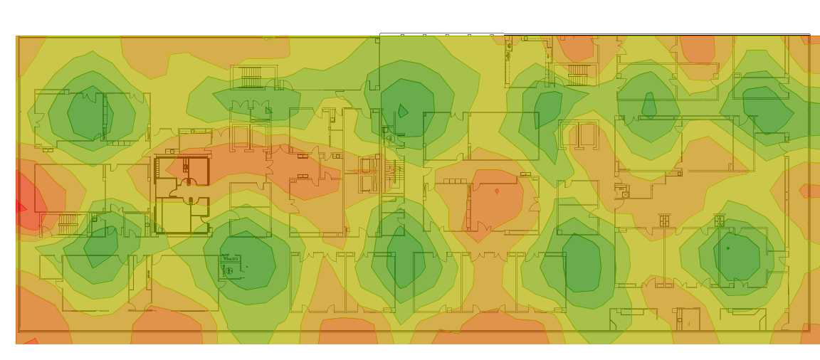

Capacity
Number of devices on this floor | Device
266 / 900 | Laptop
177 / 600 | AC Smartphone
15 / 50 | Tablet

Capacity Health 2,4 GHz
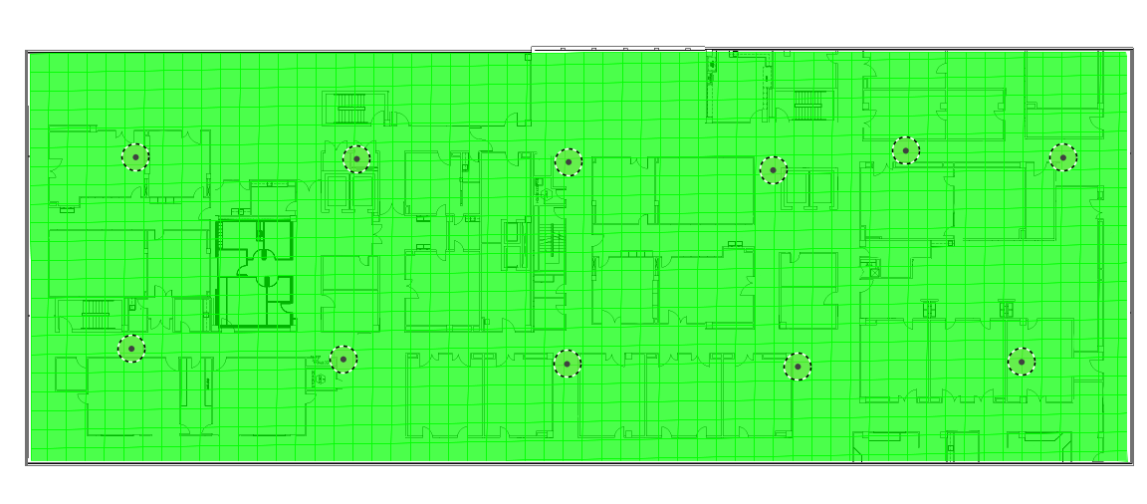

Capacity Health 5 GHz

Associated Clients 2,4 GHz
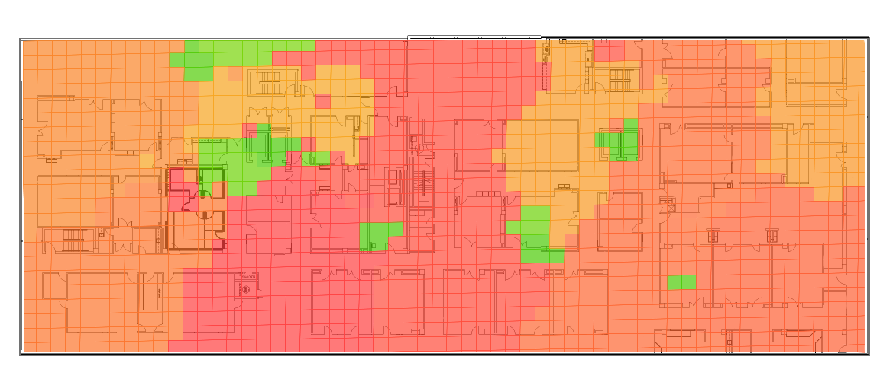

Associated Clients 5 GHz
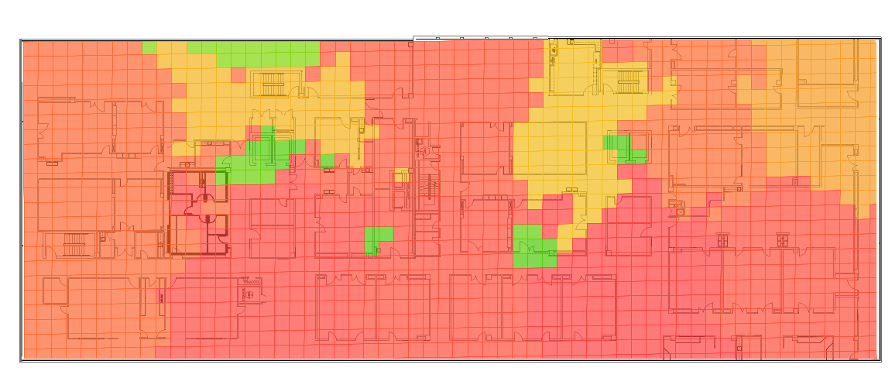

AP Serving Areas
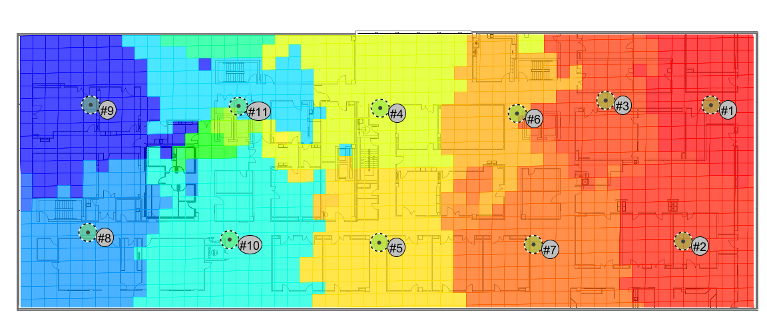

Map Floor 3

Survey Routes and AP Locations

Access Point Locations
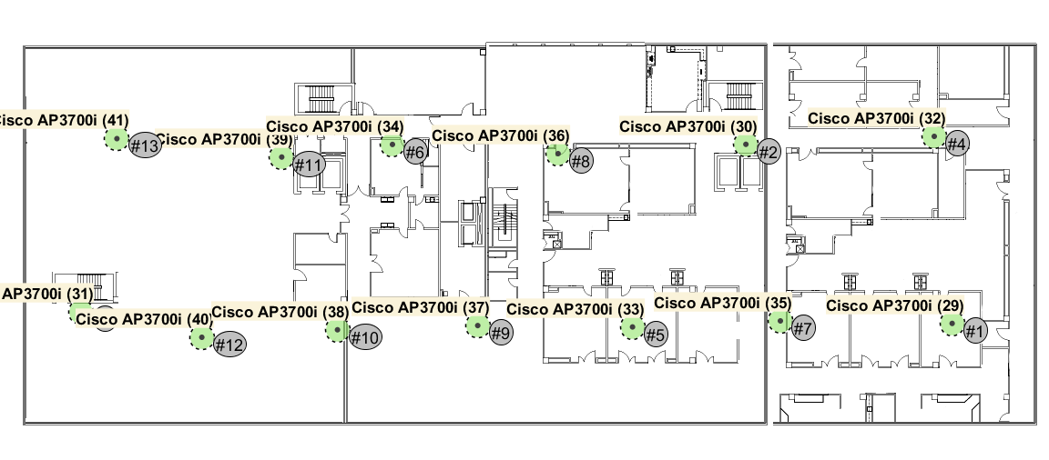
Access Points
Name: Cisco AP3700i (29) (#1) | Notes:
Radio on channel: 11
Networks:
Radio on channel: 64
Networks:

Name: Cisco AP3700i (30) (#2) | Notes:
Radio on channel: 11
Networks:
Radio on channel: 52
Networks:

Name: Cisco AP3700i (31) (#3) | Notes:
Radio on channel: 11
Networks:
Radio on channel: 64
Networks:

Name: Cisco AP3700i (32) (#4) | Notes:
Radio on channel: 6
Networks:
Radio on channel: 136
Networks:

Name: Cisco AP3700i (33) (#5) | Notes:
Radio on channel: 6
Networks:
Radio on channel: 40
Networks:

Name: Cisco AP3700i (34) (#6) | Notes:
Radio on channel: 6
Networks:
Radio on channel: 132
Networks:

Name: Cisco AP3700i (35) (#7) | Notes:
Radio on channel: 1
Networks:
Radio on channel: 116
Networks:

Name: Cisco AP3700i (36) (#8) | Notes:
Radio on channel: 1
Networks:
Radio on channel: 112
Networks:

Name: Cisco AP3700i (37) (#9) | Notes:
Radio on channel: 11
Networks:
Radio on channel: 60
Networks:

Name: Cisco AP3700i (38) (#10) | Notes:
Radio on channel: 1
Networks:
Radio on channel: 120
Networks:

Name: Cisco AP3700i (39) (#11) | Notes:
Radio on channel: 11
Networks:
Radio on channel: 56
Networks:

Name: Cisco AP3700i (40) (#12) | Notes:
Radio on channel: 6
Networks:
Radio on channel: 36
Networks:

Name: Cisco AP3700i (41) (#13) | Notes:
Radio on channel: 1
Networks:
Radio on channel: 108
Networks:

Network Health

2,4 GHz
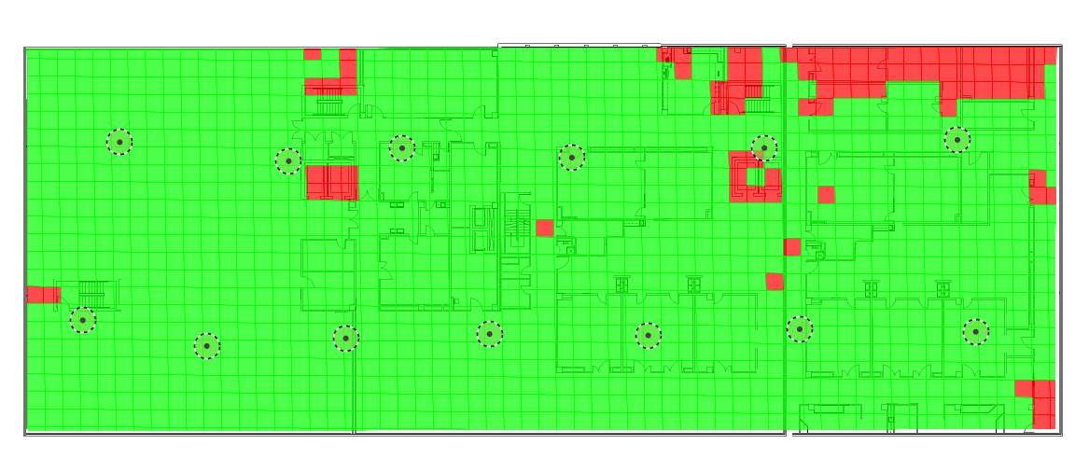

5 GHz
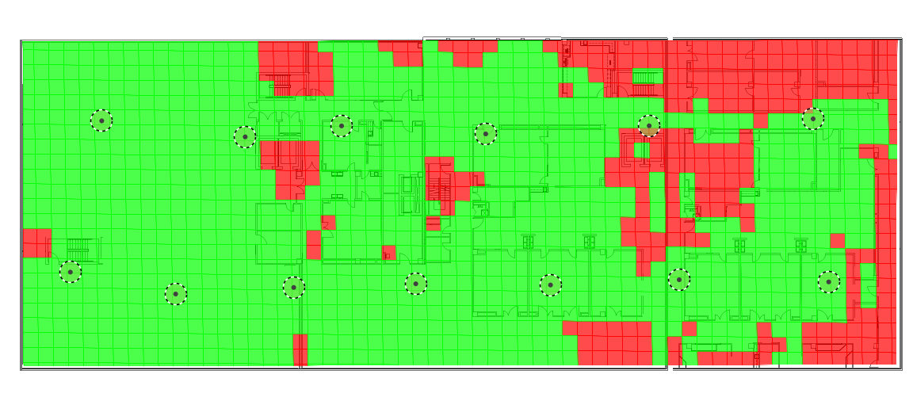

Coverage, Interference and SNR

Signal Strength 2.4 GHz
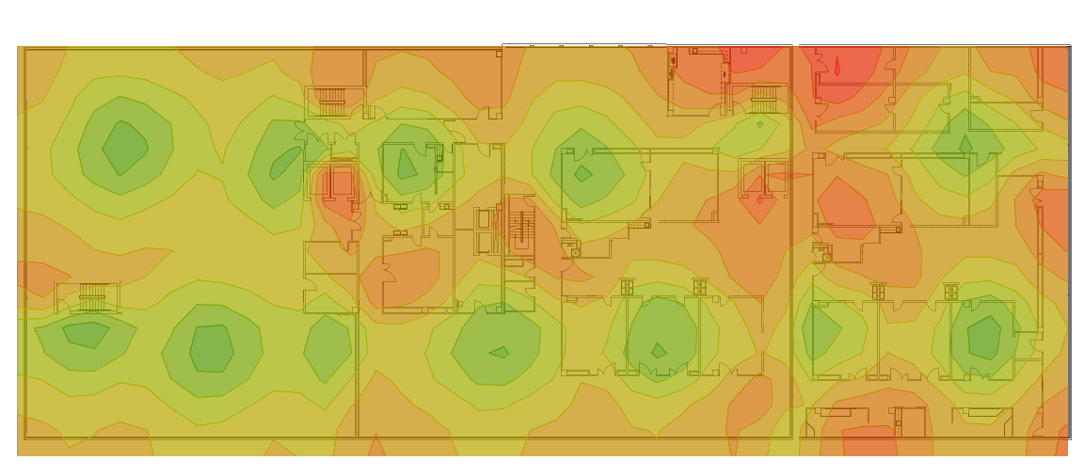

Signal Strength 5 GHz
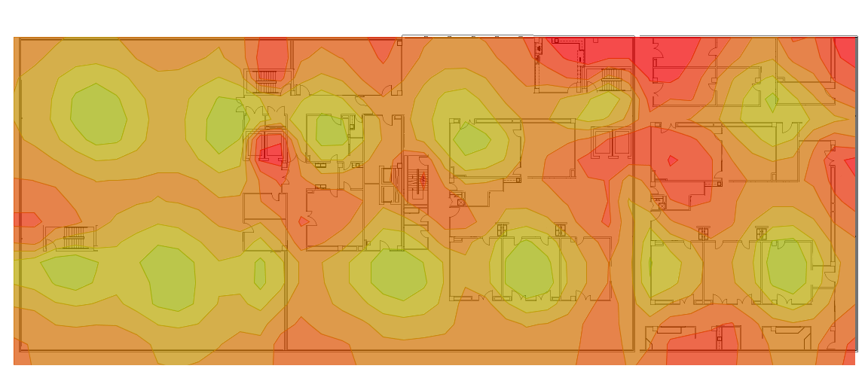

Access Point Coverage 2.4 GHz

Cisco AP3700i (29) @ Channel 11
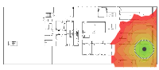
Cisco AP3700i (30) @ Channel 11
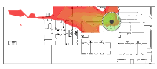
Cisco AP3700i (31) @ Channel 11
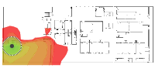
Cisco AP3700i (32) @ Channel 6
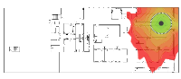
Cisco AP3700i (33) @ Channel 6
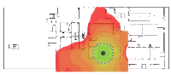
Cisco AP3700i (34) @ Channel 6
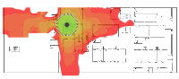
Cisco AP3700i (35) @ Channel 1
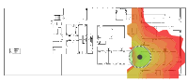
Cisco AP3700i (36) @ Channel 1
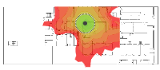
Cisco AP3700i (37) @ Channel 11
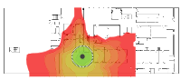
Cisco AP3700i (38) @ Channel 1
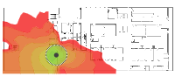
Cisco AP3700i (39) @ Channel 11
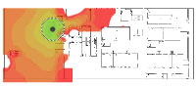
Cisco AP3700i (40) @ Channel 6
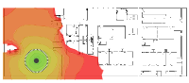
Cisco AP3700i (41) @ Channel 1
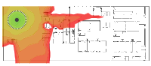

Access Point Coverage 5 GHz

Cisco AP3700i (29) @ Channel 64
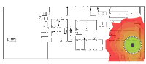
Cisco AP3700i (30) @ Channel 52
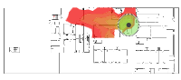
Cisco AP3700i (31) @ Channel 64
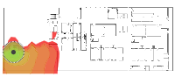
Cisco AP3700i (32) @ Channel 136
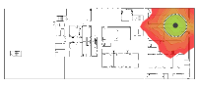
Cisco AP3700i (33) @ Channel 40
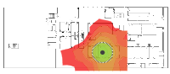
Cisco AP3700i (34) @ Channel 132
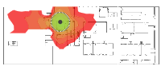
Cisco AP3700i (35) @ Channel 116
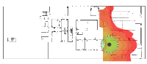
Cisco AP3700i (36) @ Channel 112
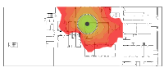
Cisco AP3700i (37) @ Channel 60
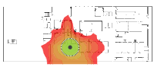
Cisco AP3700i (38) @ Channel 120
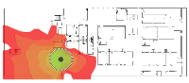
Cisco AP3700i (39) @ Channel 56
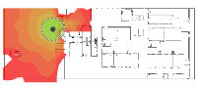
Cisco AP3700i (40) @ Channel 36
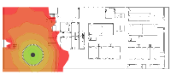
Cisco AP3700i (41) @ Channel 108
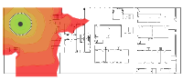

Interference 2.4 GHz
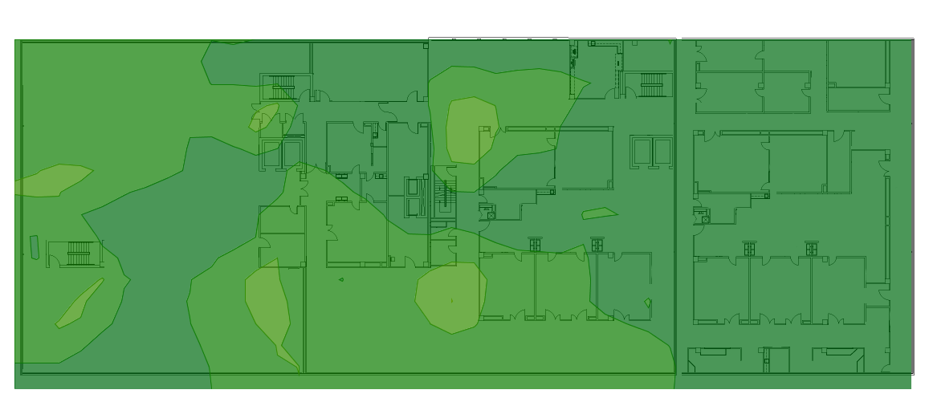

Interference 5 GHz
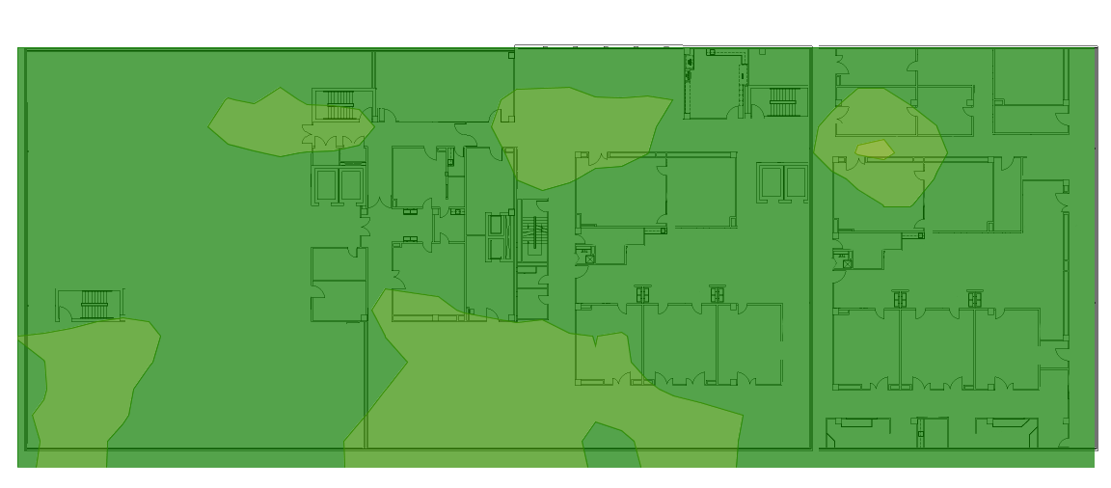

SNR 2.4 GHz
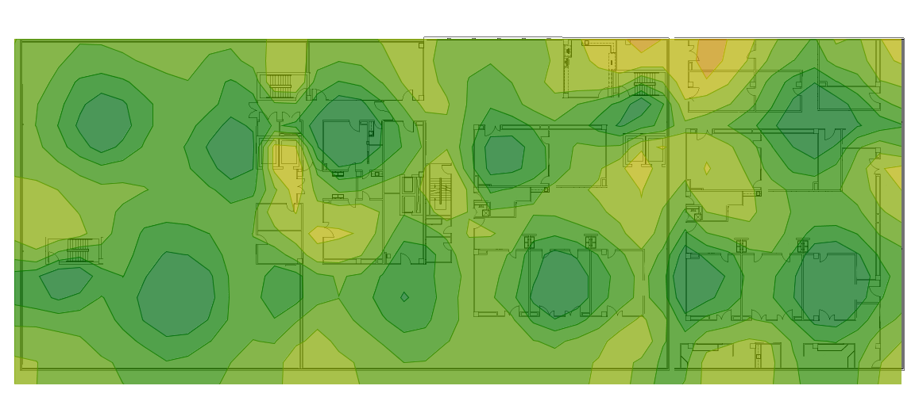

SNR 5 GHz
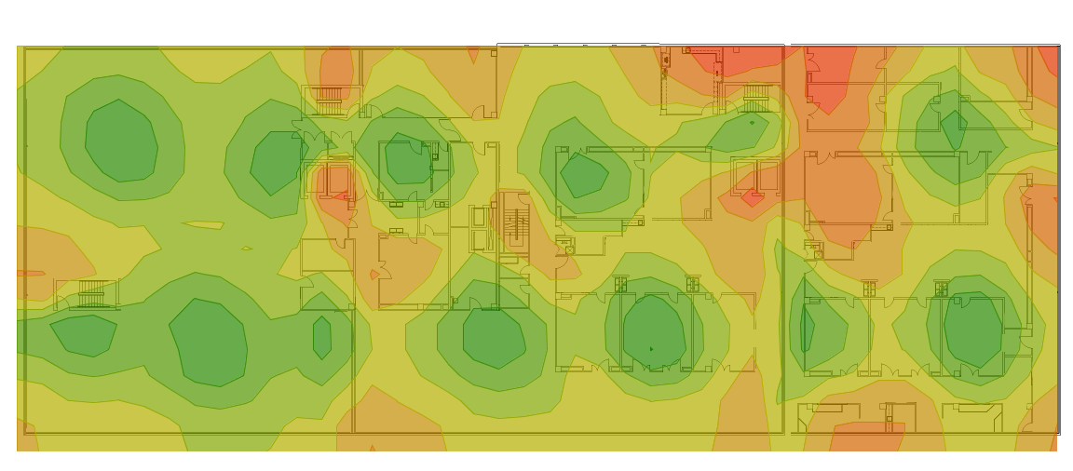

Capacity

Number of devices on this floor | Device
262 / 900 | Laptop
175 / 600 | AC Smartphone
15 / 50 | Tablet

Capacity Health 2,4 GHz
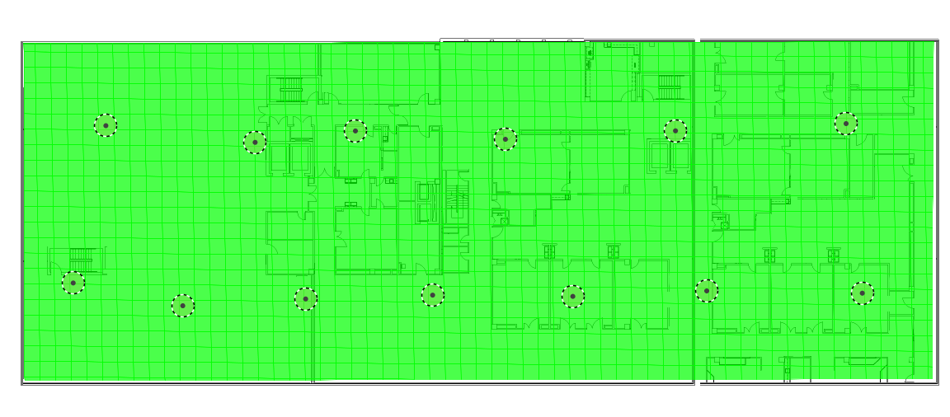

Capacity Health 5 GHz
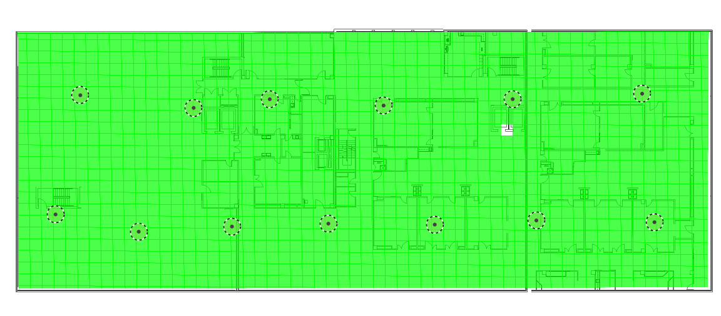

Associated Clients 2,4 GHz
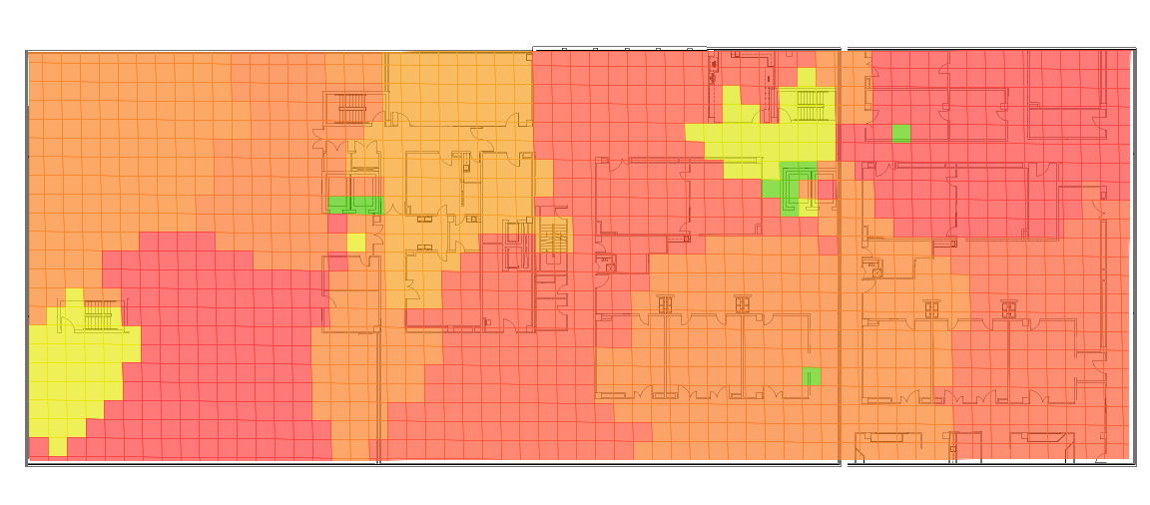

Associated Clients 5 GHz
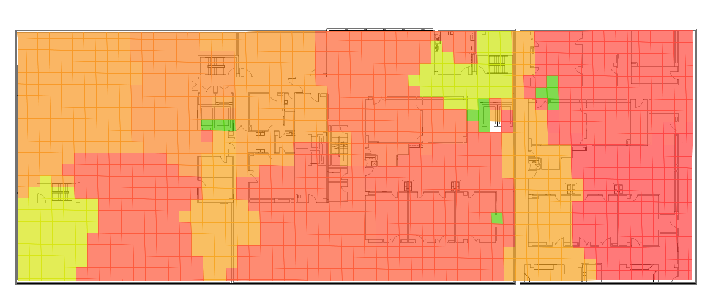

AP Serving Areas
